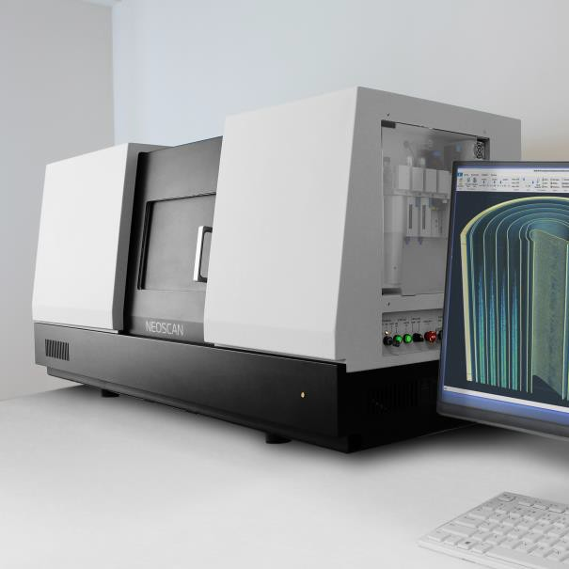

World’s first

desktop nano-CT

**SPECIFICATIONS**

**GENERAL**

**APPLICATIONS**

Pixel size at maximum magnification 40nm (1.5mm object) True low-contrast 3D resolution 300nm

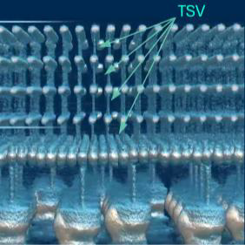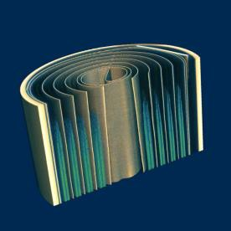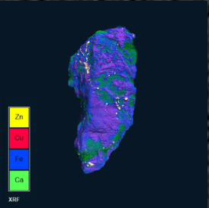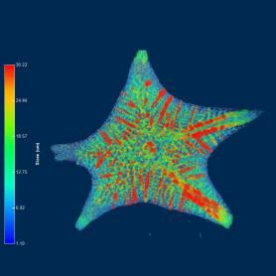

CHALCOPYRITE

LI ION BATTERY

ADVANCED GPU

JAPANESE STARSAND

Maximum scanning diameter Ø 100mm

Maximum scanning height 200 mm

Maximum physical object length 400mm

Size (WxDxH) 1540x580x740

Weight 550kg

# X-RAY SOURCE

Emitter type Transmission (open)

Energy range 20-160kV

Maximum power 16W

Smallest spot size 300nm or better Filter changer, number of positions 7

# X-RAY CAMERA

Image format 27MP CMOS /

7Mp Flatpanel Protection against radiation damage Radiation hardened

# OPTIONAL

Integrated full-field micro-XRF module Elemental mapping 3D NeoSpace Station 3D Spatial Reality

ACCESSORIES

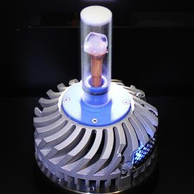 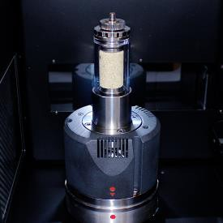

**THERMAL STAGE COMPRESSION/TENSILE STAGE**

-40°C below ambient up to 120°C +/-1000N

Neoscan microCT systems are supplied with an in-house developed all-in-one software tool for intuitive scanner control and processing data. From acquisition of a full series of 2D projection images, reconstruction into a 3D volume, to visualization and analysis of this volume in 2D and 3D, the software bundles all complementary steps from sample to result. The Neoscan software package includes an intuitive user interface, which will guide you through your straightforward workflow, allowing to use it instantly. All final and intermediate results are stored in conventional file formats and can be imported to any other software.

